1.**Install Power BI Desktop and share the final screenshot of the report view page which appears when power desktop starts.**

First Page

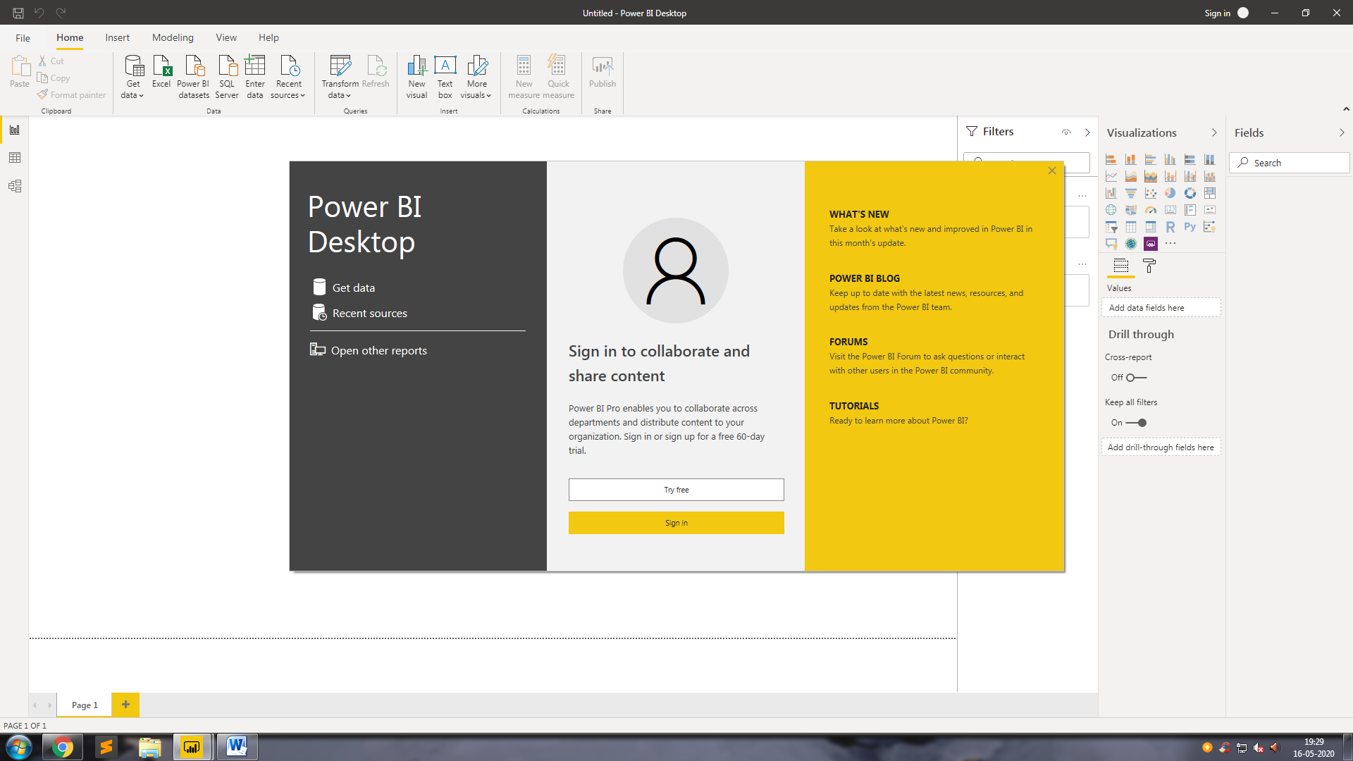

2. Prepare a document and with the following screenshot

Report View

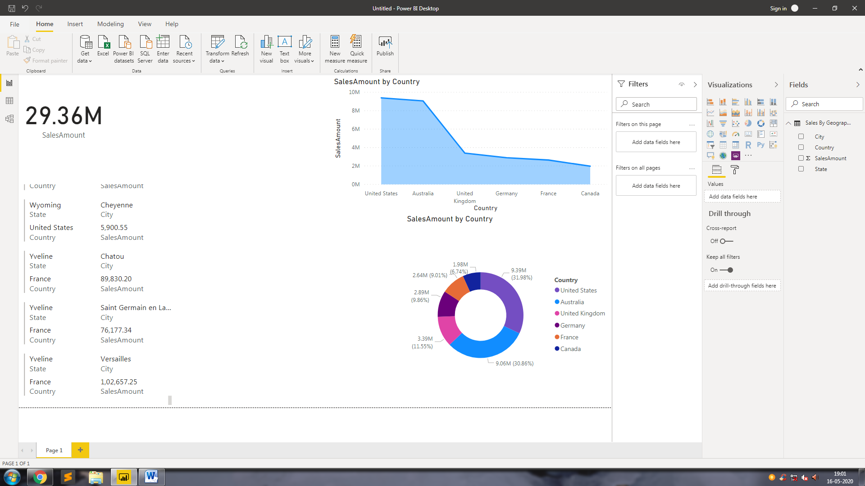

Data View

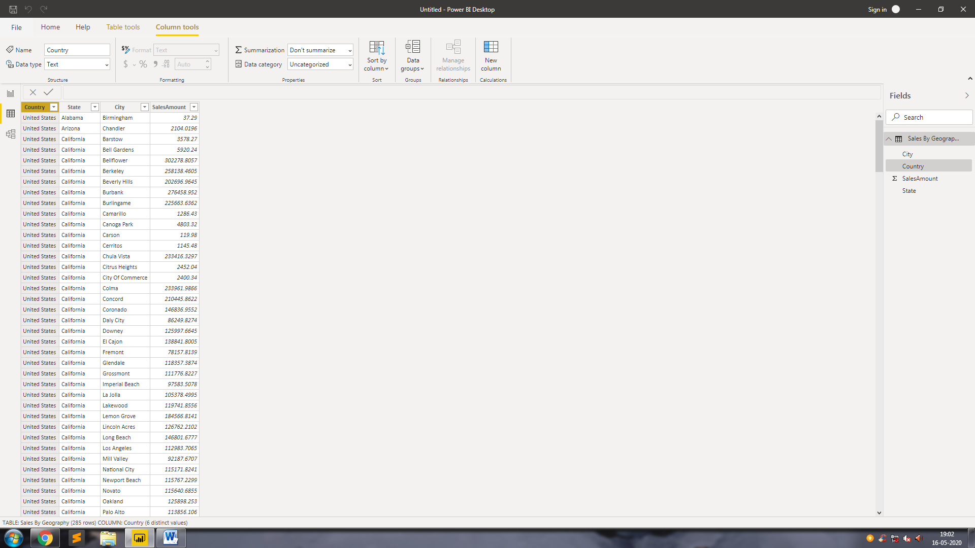

Model View

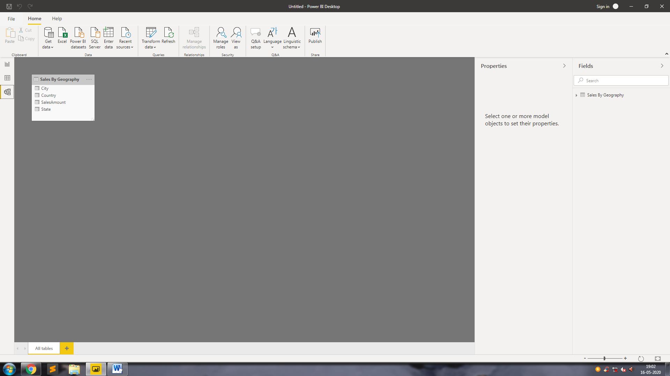

Power Query Editor

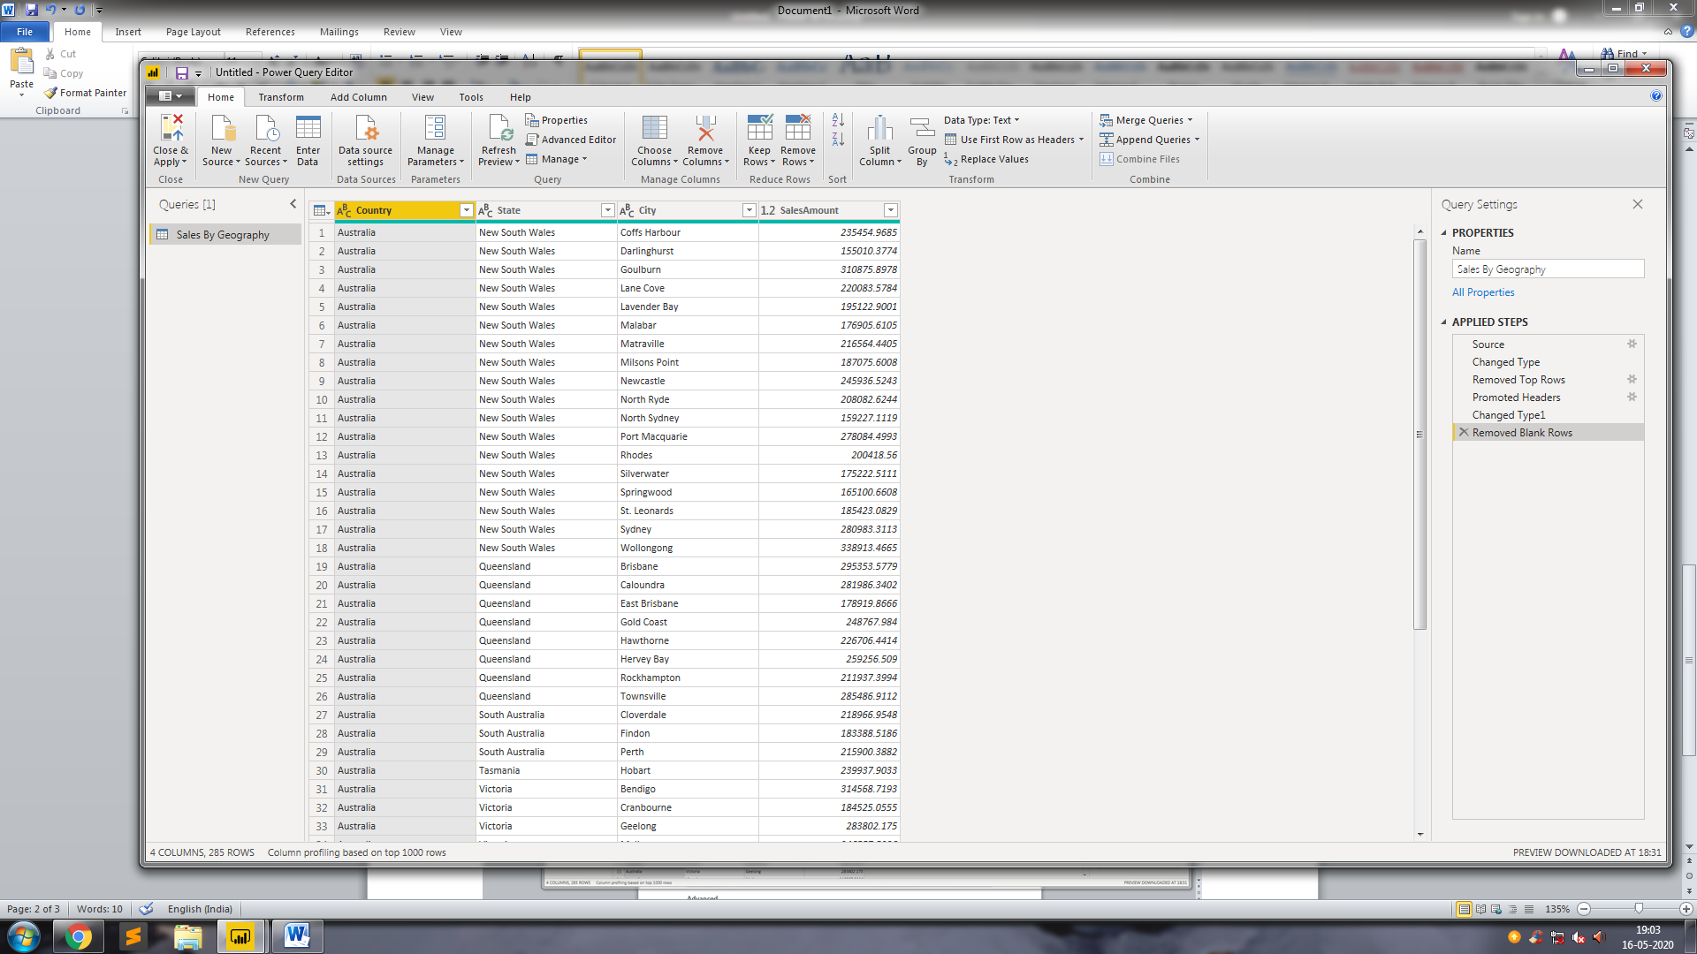

Advanced Power Query Editor

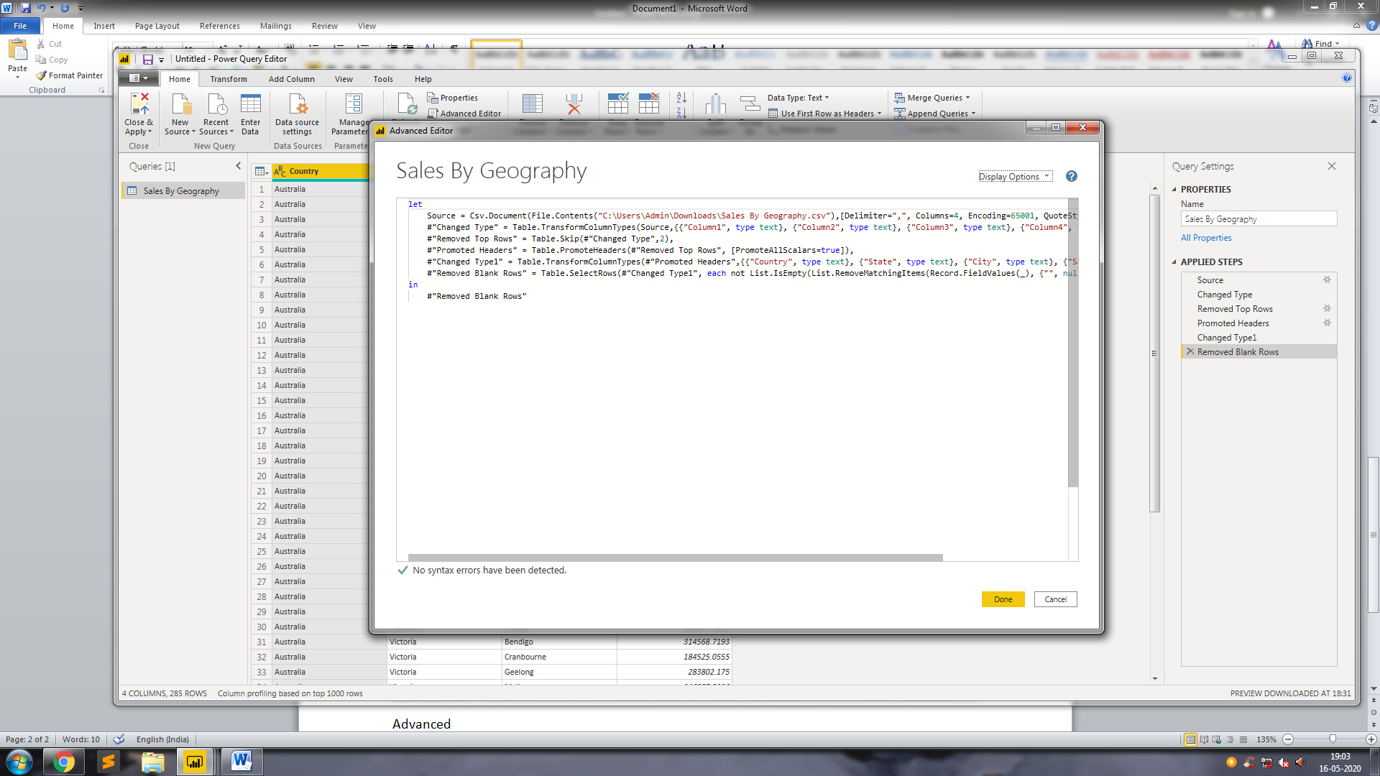

3.Prepare a document with details of the following along with their price

Pricing Comparison

|  |  |  |  |
| --- | --- | --- | --- |
|  | Power BI Desktop | Power BI Pro | Power BI Premium |
| Includes Office 365 E5 | No | Yes | Yes |
| Licensed For | Single User | Single User | Cloud Compute |
| Report Sharing | Yes | Yes | Yes |
| Exports to CSV,XLS,PDF & PPTX | No | Yes | Yes |
| Storage Limit | 10GB | 10GB | 100TB |
| Preferable For | Single Person  & Startups | Medium Or Low Budget | Big Enterprises for Dedicated Cloud Storage Resources |
| Pricing | Free | 660 Rupees Per User | 330,190 Rupees |